**Programming Assignment 2 – n-gram model**

**Name**: Ikram Hamizi

**Professor**: Bridget McInnes

**Course**: Introduction to Natural Language Processing

**Assignment**: Design and implement a Perl program called ngram.pl that will learn an N-gram language model from an arbitrary number of plain text files.

**Screenshots**:

3-gram: (Average time: 11 seconds)

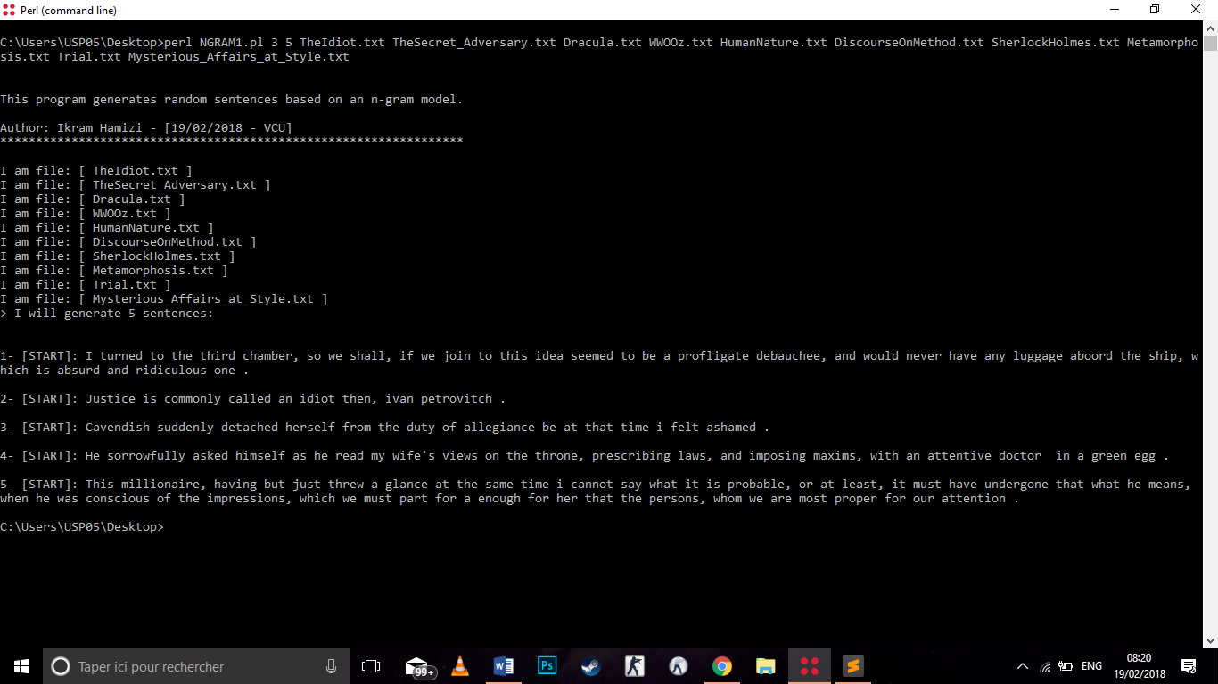

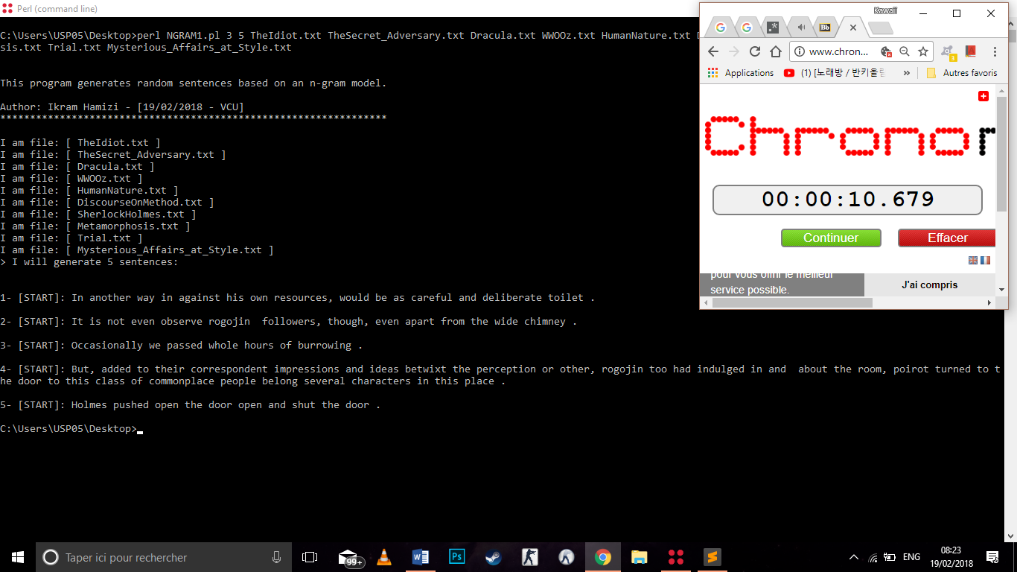

4-gram:

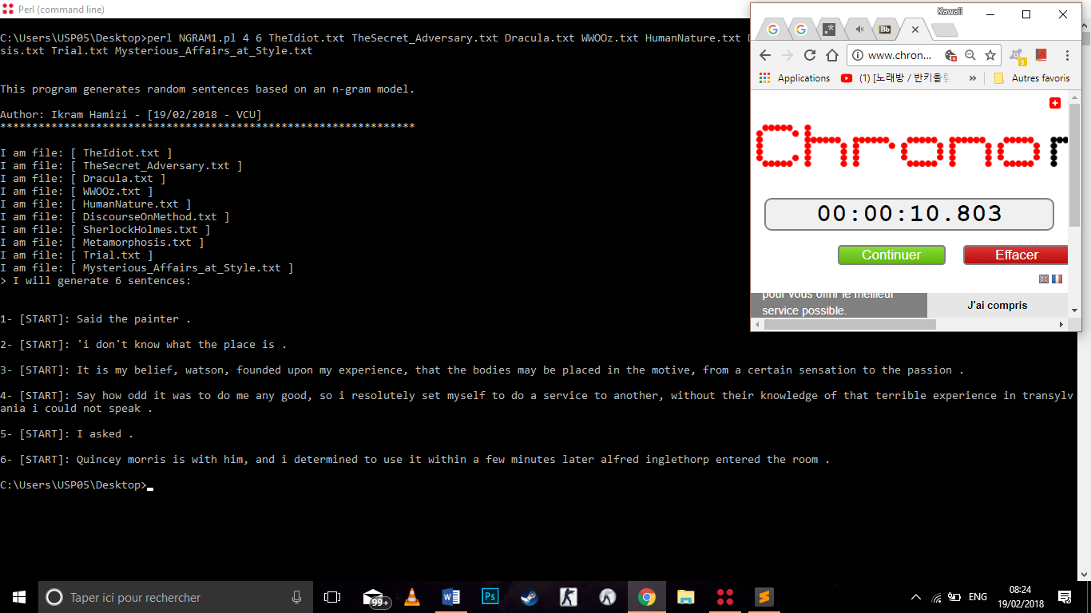

6-gram:

